**ASSIGNMENT 2**

**EMPLOYEE ER-DIAGAM**

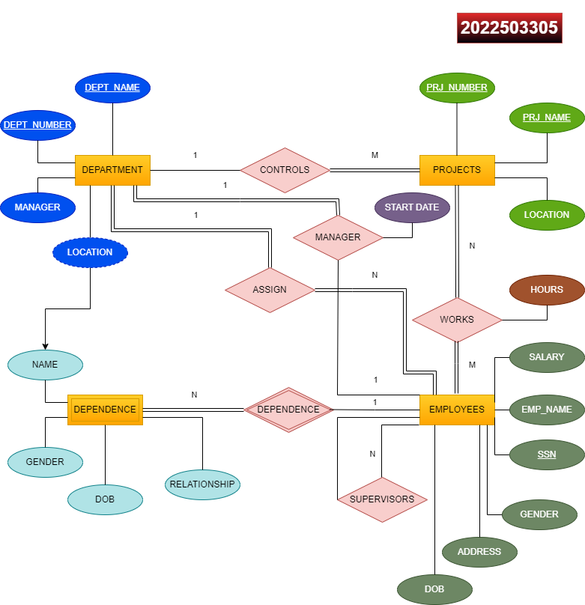

**SWIGGY ER-DIAGRAM**

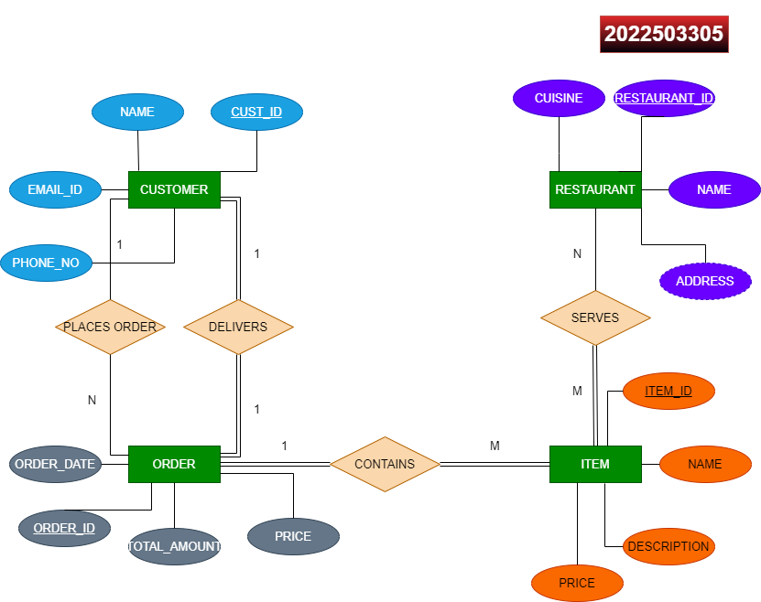

**UNIVERITY DEPARTMENT ER-DIAGRAM**

